Project Design Phase-II
Data Flow Diagram & User Stories

Date | 3 October 2026
Team ID | SWTID-2026-9684
Project Name | Implement Client Script & UI Policy (Incident)
Maximum Marks | 4 Marks

Data Flow Diagrams:
A Data Flow Diagram (DFD) represents how Incident data moves through the ServiceNow form, UI Policy controls, Client Scripts, and the Incident record.
Example: DFD Level 0 (Industry Standard)
DFD for the proposed solution:
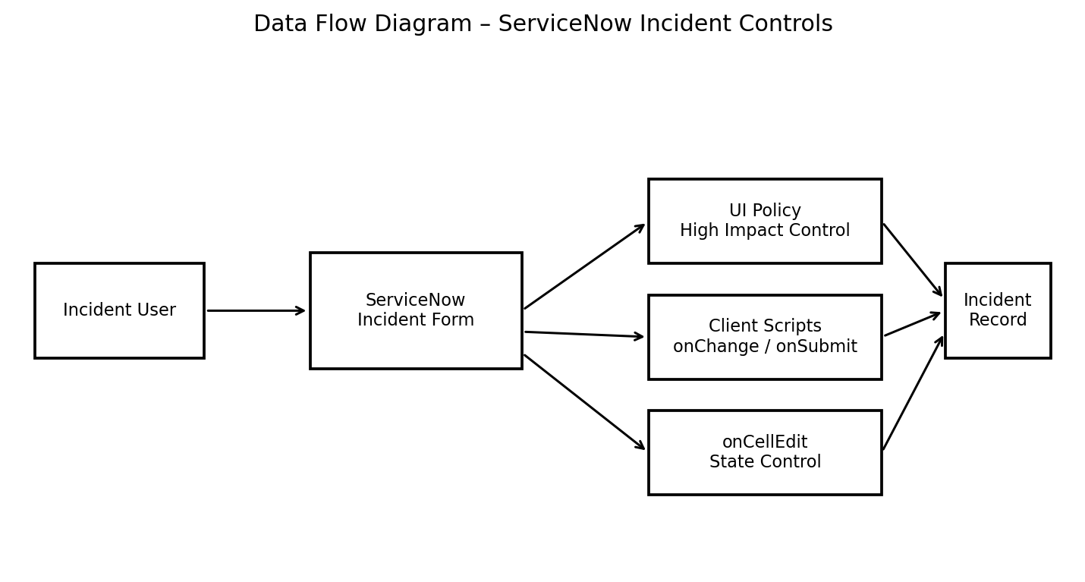


User Stories
Use the below template to list the user stories for the ServiceNow Incident solution.
User Type | Functional Requirement (Epic) | User Story Number | User Story / Task | Acceptance criteria | Priority | Release
ServiceNow User | High Impact Control | USN-1 | As a ServiceNow user, I can select Impact as High so that the High Impact Control UI Policy is triggered. | Impact = High activates the configured UI Policy. | High | Release-1
ServiceNow User | Mandatory Assignment | USN-2 | As a ServiceNow user, I must enter Assigned To for a High impact Incident. | Assigned To becomes mandatory when Impact = High. | High | Release-1
ServiceNow User | Urgency Automation | USN-3 | As a ServiceNow user, I want Urgency to be automatically set to High when Impact becomes High. | Urgency is set to High and an information message is displayed. | High | Release-1
ServiceNow User | Urgency Control | USN-4 | As a ServiceNow user, I cannot manually change Urgency while the High Impact UI Policy is active. | Urgency becomes read-only for High impact. | Medium | Release-1
ServiceNow User | Save Validation | USN-5 | As a ServiceNow user, I cannot save a High impact Incident when Assigned To is empty. | Save is blocked and an error is displayed for Assigned To. | High | Release-1
ServiceNow User | List Edit Control | USN-6 | As a ServiceNow user, I cannot change State directly using Incident list editing. | An alert appears and the State value remains unchanged. | High | Release-1
ServiceNow User | Form Update | USN-7 | As a ServiceNow user, I can change State from the Incident form. | The State change is saved successfully through the form. | Medium | Release-1
ServiceNow Admin | Reverse Condition | USN-8 | As an administrator, I can verify that controls are reversed when Impact changes from High to Medium. | Assigned To is no longer mandatory and Urgency becomes editable. | Medium | Release-1
ServiceNow Admin | Testing | USN-9 | As an administrator, I can test all configured UI Policy and Client Script behaviors. | Mandatory, successful save, reverse condition, list blocking, and form update tests pass. | High | Release-1

